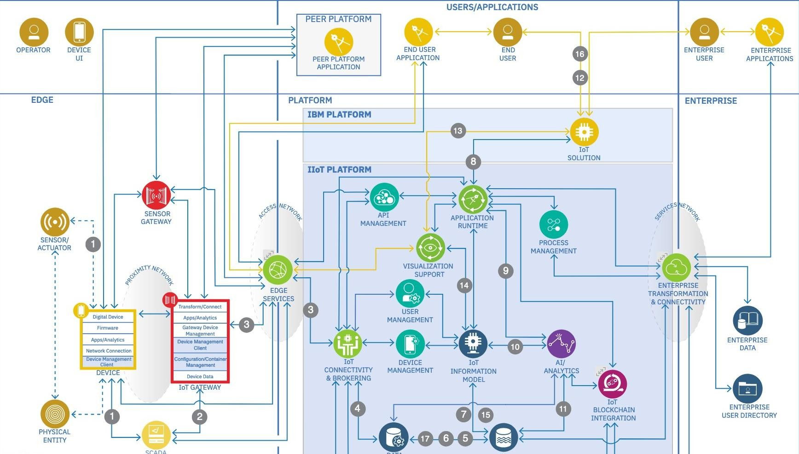

PROJECT DESIGN PHASE-I

**SOLUTION ARCHITECTURE**

|  |  |
| --- | --- |
| **Date** | 11 October 2022 |
| **Team ID** | PNT2022TMID51059 |
| **Project Name** | Gas leakage Monitoring and Alerting System for Industries |
| **Team members** | Deepak Chakravarthi P (Team leader)  Gomathi Naayagam I S  Ganeshamoorthy I  Ganesh |